## 

## ****R J Rajivarthini****

## ****2403717624322042****

## ****Home Appliance Control System****

## ****4. User Interface Requirements**** The HACS GUI shall be simple, consistent, and accessible for homeowners, guests, and administrators, emphasizing clarity and minimal learning effort.

**4.1 Look and Feel Requirements**  
Each screen will show the system name, slogan, and footer with date/time. A consistent color scheme will be used, with clear status indicators (Green = ON, Red = OFF, Grey = Inactive). Navigation bars with icons and labels, uniform buttons, sans-serif fonts (min. 12pt), and highlighted critical functions (e.g., Red for Emergency Shutdown) will ensure clarity and readability.

**4.2 Usability Requirements**  
The GUI will support non-technical users with menu-driven, icon-based navigation, accessible within three clicks. New users should complete basic tasks (e.g., ON/OFF appliances) within two minutes. Clear error messages, immediate feedback, large buttons, spacing, and optional tooltips will ensure easy and error-free interaction

### ****Appendix D: Task Log and Outputs****

**Table D1.0 Tasks Undertaken**

| **Task Name** | **Description** | **Technique(s) Used** | **Notes** |
| --- | --- | --- | --- |
| Requirements Gathering | Identified user needs for monitoring and controlling appliances remotely. | Interviews, brainstorming, document analysis | Helped in defining functional requirements. |
| System Scope Definition | Outlined system boundaries, users, and appliances covered. | Context diagrams, use case identification | Provided foundation for requirements specification. |
| Functional Requirements Specification | Documented actions like ON/OFF, scheduling, and adding appliances. | Use case modeling, user stories | Captured all user and system functions. |
| Non-Functional Requirements Specification | Defined security, reliability, and scalability constraints. | Quality attribute checklists, expert review | Ensured system performance and usability. |
| Interface Design | Designed GUI structure and usability features. | Wire framing, prototyping, usability heuristics | Ensured clarity, consistency, and accessibility. |

Table 52.0 Sections affected by the various tasks.

**Table D2.0 Sections Affected by Tasks**

| **Task Name** | **Outputs** | **Section(s)** |
| --- | --- | --- |
| Requirements Gathering | User Needs, Appliance Scenarios | 1.2 Scope, 2.1 Introduction |
| System Scope Definition | System Boundaries, Actors | 1.4 Constraints, 1.8 Assumptions |
| Functional Requirements Specification | Use Cases, Functional List | 2.3 Functional Requirements, 7.0 Use Cases |
| Non-Functional Requirements Specification | Security, Reliability, Scalability | 5.3 – 5.6 Non-Functional Requirements |
| Interface Design | GUI Requirements, Usability Criteria | 4.0 User Interface Requirements |

# Appendix E: Contributions

**Table E1.0 Document Contributions**

**Contributor Name Sections Worked On**

1. DHARSHINI - Introduction, Product Overview

H.RAJESHWARI - Functional Requirements

G.SHANGARA VADIVEL - Non-Functional Requirements, Operating Environment

S. ARIVU SELVAN - Appendices A, B, C,D, E.

R.J. RAJIVARTHINI - UI Requirements,Appendices F, G,Use case diagram,context diagram.

**Appendix F: Meeting Agendas/Minutes**

**Table F1.0 Meeting Dates/Times**

| ID | Meeting Date/Time | Agenda |
| --- | --- | --- |
| 1 | 10/08/2025, 2:00 PM – 3:00 PM | Requirement Gathering & Assigning Sections |
| 2 | 15/08/2025, 4:00 PM – 5:00 PM | Review of Functional and Non-Functional Sections |

**Agenda & Minutes (Sample for Meeting 1):**

**Agenda:** Finalize project scope, identify key appliances, assign roles.

**Minutes:** Agreed on HACS scope (microwave, sprinkler, AC, pet feeder, security system). Assigned tasks: Student A (template), Student B (requirements), Student C (UI), Student D (review).

# Appendix G: Problem Investigation Reports

**Purpose:**

To document problems encountered during requirements elicitation and SRS preparation, along with their resolutions.

Problem ID Description Resolution

|  |  |  |
| --- | --- | --- |
| P1 | Ambiguity in appliance control operations requirements | Discussed with team and clarified actions |
| P2 | Missing non-functional requirement details | Researched IEEE SRS standards and updated |
| P3 | Confusion over context model format | Referred to IEEE examples and created diagrams |

**Usecase Diagram:**

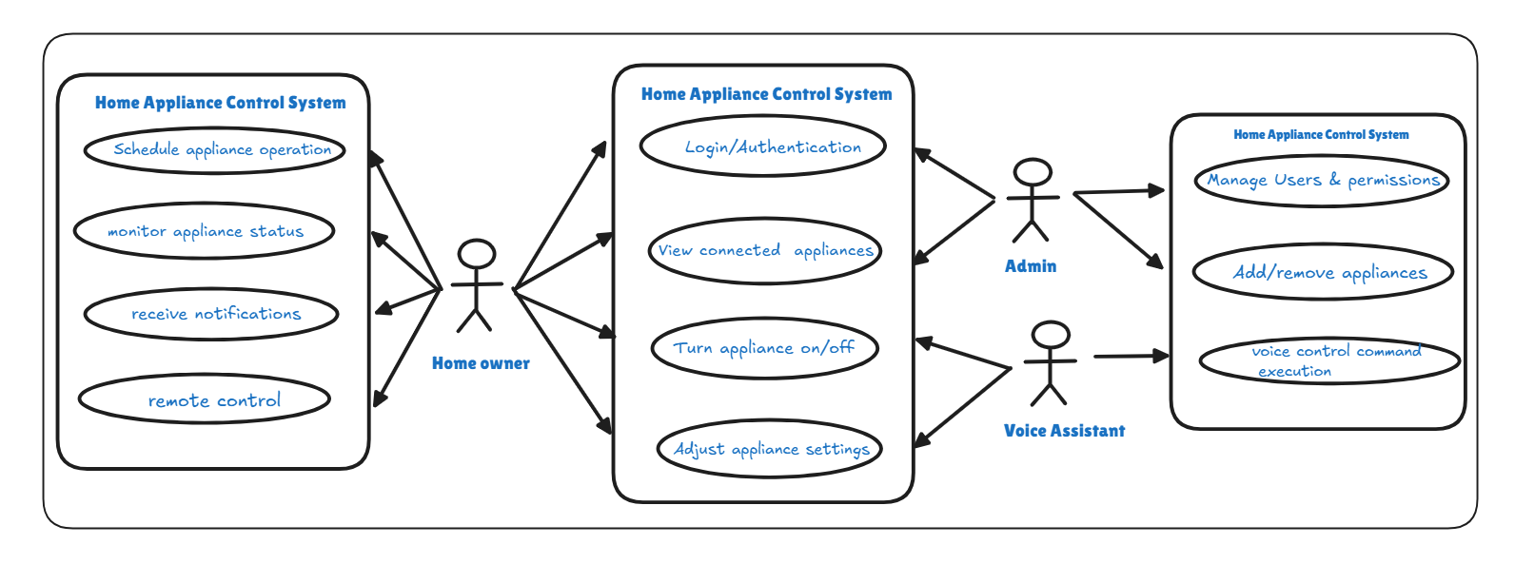

**Context Diagram:**

